Mountains
Student’s Name
Institutional Affiliation
Date of Submission

Types of Mountain
Introduction
All over the world, mountains are formed due to pressure, compression, shear, and tension. The physical characteristics of the mountain ranges depend on the pressure exerted. Mountains are formed differently hence different types of mountains, and this can be due to crunching of tectonic forces on one another; it can slide past one another or magma eruptions from the Earth. The formation and appearance of the mountains make them different all over the world. Mountains and volcanoes are beneficial to human beings (Pinter and Brandon, 1997). There are various mountains, including volcanic peaks, Fold Mountains, Block Mountains, Dome Mountains, and Plateau Mountains.
Fold Mountains
These are the most common types of mountains in the world. They are large mountain ranges that stretch thousands of kilometres. It is formed by a process called orogeny. This is where tectonic earth plates that are one or two are pushed together. Continental crust is linked to folding mountains created by convergent plate boundaries when tectonic plates are crushed on one another (Risch et al., 2010). Most of the Fold Mountains are on the edge or former edge of continental plate boundaries; this is because of crustal formation, resulting from tectonic activity leading to crusting formation at the border. Examples of these mountains include the Rocky Mountains in North America and the Himalayan Mountains in Asia.
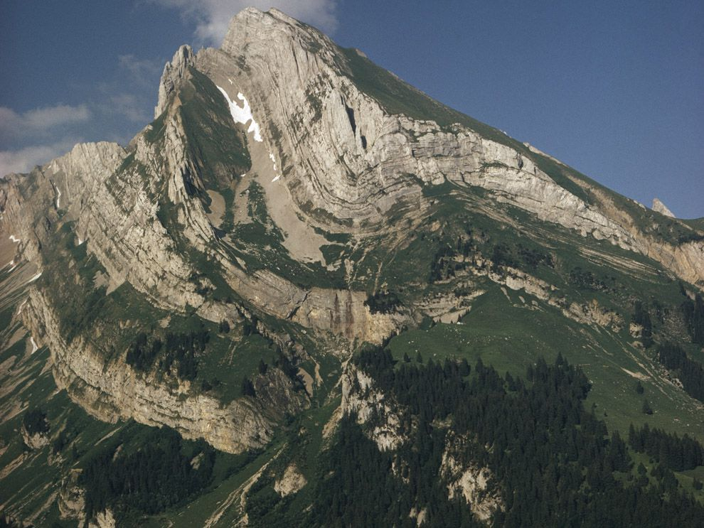

Fault-Block Mountains
They are also referred to as Block Mountains. It is formed in two ways; by compressional forces that happen when the block of land between the two faults are uplifted and in cases where tensional muscles occur where the ground on their side of the central blocks sinks (Risch et al., 2010). This happens when materials or blocks of rocks from the Earth are pushed upwards while others down. The Earth falls apart instead of folding. The great sheer of rock faces is what distinguishes Fault Mountains from others.
Unlike Fold Mountains with plate collisions that get folded, Block Mountains break up into chunks that can move up or down.
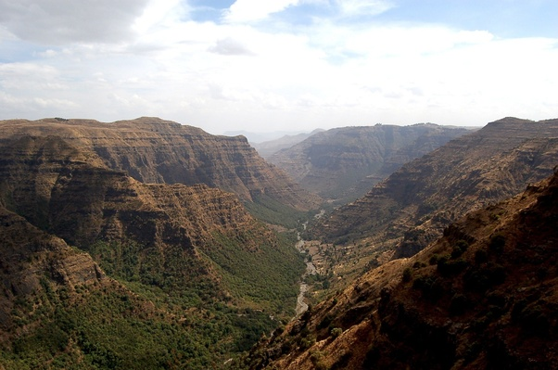

Dome Mountains
It is formed when vast magma numbers are pushed up from below the Earth's crust, but it does not always reach the surface and erupts. Before the eruption, the magma source is usually driven away, and the rock that has been formed cools, hence hardening and forming a dome shape (Pinter and Brandon, 1997). The circular mountain range is a result of erosion works at the top because of the dome, which is higher than its surrounding. What happens in Dome Mountains is when rock melts due to the heat under the Earth's surface. They are not as high as Fold Mountains. This is because the force that pushes magma that is under the body is not that high. As time goes, the magma cools and forms a dome shaped Mountain.
An example is the Sierra Nevada in range in California, which was made from granite. It was made from a large amount of magma that was pushed upwards, forming a mountain. Granite cannot be eroded easily since it is tough as compared to other mountains.
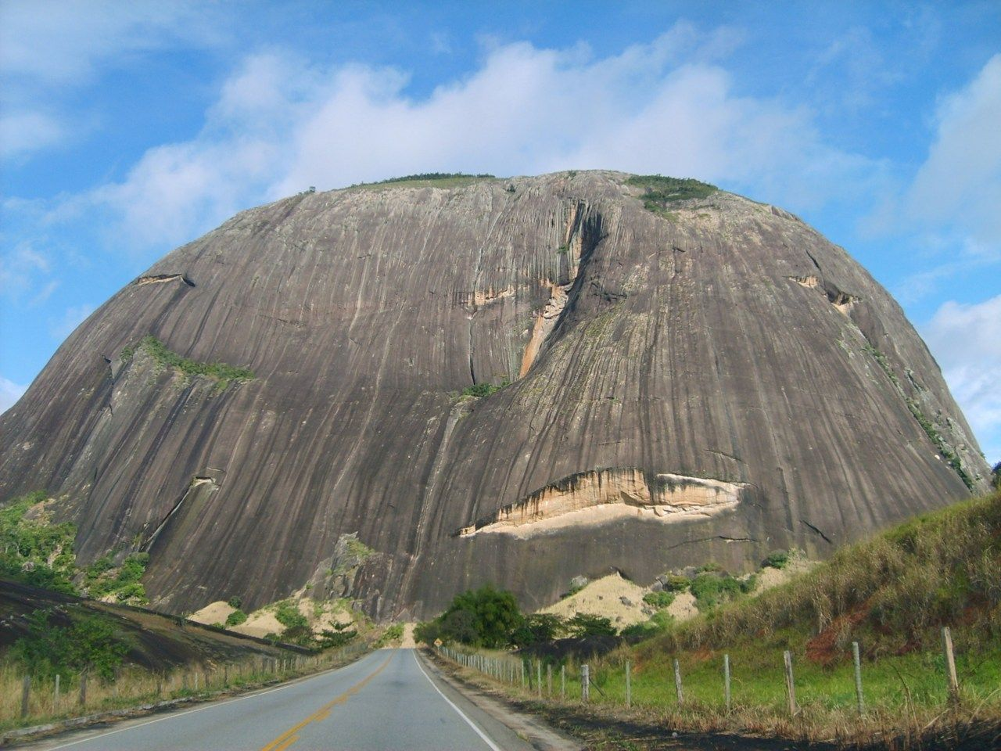

Volcanic mountains
These mountains are built by liquid or solid material from the Earth. It is formed when the magma from the Earth erupts into its surface. It comes out in the form of lava, ash, volcanic gases, and rock. According to Pinter and Brandon (1997), a volcanic vent happens because of such materials; therefore, building a mountain. When tectonic forces move, it creates a volcano alongside the plate boundary, which later forms a hill. Basalt, which is the material that is emitted and has a low viscosity, causes a shield volcano that has a gently sloping cone. Examples include Mt Rainier in the US and Mt. Fuji in Japan.
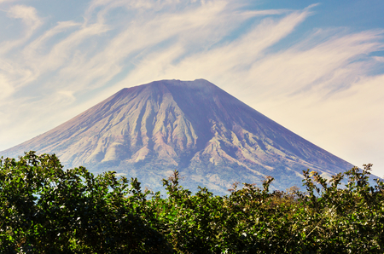

Plateau Mountains
Internal activities of the Earth form the primary basis of its creation, mostly shown by erosion. It is when running water cuts deep channels into the region, thus forming mountains. It is created by three tectonic forces: volcanic, crustal formation, and thermal expansion. On many occasions, tall mountains are created by rivers that cut deep into the plateau. Some altitude and relative relief characterize plateau Mountains. It is an area which is bound by escarpments and flat upland. The Tibetian table is the largest and highest in East Asia which results from two tectonic forces that culminated in creating the plateau mountain. The Himalayan mountain range was formed where land shrunk along the seam of the collision.
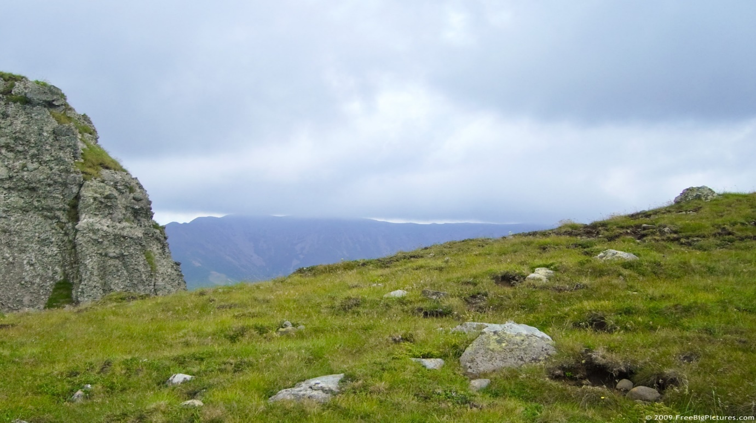
The Alps is a type of mountain range that is formed as a result of tectonic plates. This happens when two substantial tectonic plates collide slowly and cause the ground to21 to be pushed, generating the highest peak mountains in Europe (Pinter and Brandon, 1997). This type of mountain range belongs to block mountains. The tallest Alps Mountain is Mont Blanc. Different temperatures from North, West, and South of Europe in the Alps cause temperature variations. It causes five types of climate in the area. Glaciers and snow cover the top of Alps Mountain. Different plants and animals live in various climatic regions, and others cannot be found anywhere else in the world. When snow and ice melts, it forms rivers and lakes. The main economic activity in the Alps is tourism.
Earthquakes occur when seismic waves pass through Earth's rocks caused by a sudden shaking of the Earth. The energy that is stored in the Earth's crust and released suddenly causes seismic waves. There are various types of earthquakes, which include volcanic, tectonic, and explosion.
Tectonic earthquakes
It occurs due to the movement of tectonic plates that slowly and gradually. These plates of plates arise in various forms; it can be towards each other, slide on each other's, and collide with each other. When two tectonic forces move slides on each other, a considerable tremor is caused. This is the primary type of earthquake that occurs in the world (Mogi, 1967). Tremors caused by tectonic forces are always fatal, and when the magnitude is high, a lot of destruction is generated, including bringing down cities. This type of earthquake is located along the rim of the Pacific Ocean. This is because the plates of oceanic crust sinks or subdues under another dish. This causes rupturing and slipping between plates and within containers.
Volcanic earthquakes
Compared to the tectonic earthquake, volcanic earthquakes do not occur often. It happens before or after an eruption. Volcanic mountains happen in two types, long-period volcanic mountains, and volcano-tectonic earthquakes. Volcano- tectonic earthquakes occur during an outbreak. Discharge of the magma from the Earth's crust, thus leaving a space after, is what happens during an earthquake. Therefore, the space left should be filled, and in the process, rocks move toward freedom, thus causing severe earthquakes. During a volcanic activity, the vents are blocked by the magma, thus creating a pressure that becomes hard to release. When the pressure is built up, it becomes unbearable, and a massive eruption is released.
A long-period volcanic earthquake arises from a volcanic eruption. When it is almost days to a massive explosion, there are rapid changes in the Earth's crust due to magma hence triggering seismic waves. The volcanic tremor is mainly found in the ring of Fire, a convergent and transform boundary in the Pacific Ocean basin (Mogi, 1967). It also occurs in the Mediterranean-Asiatic belt. Due to convergence, the Indian plate runs into the Eurasian plate, thus creating the largest mountain ranges in the world.
Explosion earthquakes
Nuclear explosions are the leading cause of this earthquake. The man mainly triggers this kind of earthquake, representing the leading cause of nuclear war today. Tectonic plates do not play a role in its occurrence; for example, the USA in 1930 conducted atomic tests, which was the leading cause of the destruction of many towns and villages. Areas that produce hydrocarbon in the USA like Oklahoma pose a significant threat to the population that lives around it; therefore, it is essential to consider strategies to prevent an earthquake.
Collapse earthquake
These are a tiny type of earthquake and are mostly found next to underground mines. It can also be referred to as mine bursts; they are caused by pressure from within the rocks. This type of earthquake causes the collapse of the roof of the mines, causing more earth tremors. This kind of earthquake is mainly found in small towns where underground mines are taking place.
Humans should not live around the Wasatch front because geologists have conducted several research and have shown potential hazards that may cause to a population. Several fault lines are more significant than had been thought before. There will be more damage to schools, homes, businesses, buildings, and infrastructure if a massive earthquake occurs. More research is conducted to obtain information if there fault lines that may lead to tremors in the future.
Tectonic forces cause earthquakes and volcanos because of tectonic stress. When stress is applied to rocks, it causes different shapes. It also depends on the stone's response in terms of type, temperature, and pressure conditions. It is therefore creating a reaction which are elastic deformation, plastic deformation, or fracturing. This can lead to an earthquake because too much heat on rock or Mountain causes magma to erupt, creating a space that must be filled in filling a severe earthquake. When pressure is the build-up, there is a high chance that an earthquake might occur.
Volcanos and earthquakes have benefits in our modern-day. It has immensely significantly contributed to our agricultural activities. Because of the breakdown of volcanic materials and weather that increase the fertility of the soils on Earth; thus, more food will be produced. People in such a society will thrive economically as more foods will be sold and stored, thus fostering prosperity. The heat that is in the volcanic systems helps produce geothermal energy. Their magma that erupts from deep volcanos minerals are mined, including copper, zinc, gold, and silver. This will benefit society in terms of economic, social, and political development. More people will have jobs, proper education, and better health care. Poverty rates will reduce since the people will be to engage in different activities that will provide income.
Earth tectonic forces are fundamental because it created coastlines and tides' motion; hence, without them, the ocean could not have existed. Through the process of subduction, mountains are built by plates running into one another, slide apart, and skim past one, triggering earth-shattering quakes creating oceans that are all over the world (Stewart et al., 2014). Plate tectonics is essential since it acts as a global thermostat. This is achieved when carbon-dioxide is spewed into the atmosphere through volcanoes, which helps to retain more heat. When the sun becomes bright and hot, rainfall takes carbon dioxide from the atmosphere then plate tectonics subdues it into the Earth's mantle, thus locks it away. The Earth's temperature is kept stable from the cycle, which enables the Earth to support life.
Earth tectonic forces are fundamental since it regulates our atmosphere over some time. It is imperative to human beings since it provides heat that keeps us going. Human beings also benefit mostly through earthquakes and volcanos. For example, fertile soils, valuable minerals, and heat produced during the process can generate electricity. This will improve the lives of many people all over the world.
Conclusion
Mountains in the world play a significant role in determining the climate of various places in the world. Favorable climatic conditions favor agricultural activities and support human life and animals. Due to the formation of multiple mountains, the process has impacted many people's lives through civilization. Earthquakes are very hazardous when it happens as it destroys human life and property. Therefore there is a need for more strategies to avoid predominantly human-made such as explosion earthquakes. There are various types of mountains in the world that are formed as a result of earthquakes activities. This has created industries such as tourism to grow. Mountains and volcanos benefit human beings in their everyday lives.

References
Frisch, W., Meschede, M., & Blakey, R. C. (2010). Plate tectonics: continental drift and mountain building. Springer Science & Business Media.
Mogi, K. (1967). Earthquakes and fractures. Tectonophysics, 5(1), 35-55.
Pinter, N., & Brandon, M. T. (1997). How erosion builds mountains. Scientific American, 276(4), 74-79.
Stewart, R., Aguiar, O., Artuso, G., Aristizabal, C. I. O., Ackerman, J. R., Trentadue, W., & Robinett, R. (2014). EARTH'S OCEANS; A THEORETICAL APPROACH HOW INTERCONNECTED CONTINENTS AND HIGH ALTITUDE MOUNTAIN GLACIERS FORMED THEM. International Journal of Astronomy and Astrophysics Research, 2, 130.

